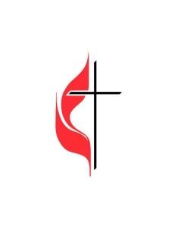
September 8th-UMYF- 3:30pm-5:30pm
September 15th-Adventure Air-12:30pm-3:00pm
September 22nd- UMYF- 3:30pm-5:30pm
October 13th UMYF- 3:30pm-5:30pm
October 25-27th-Virginia Creeper Trail Retreat
November 10th- UMYF- 3:30pm-5:30pm
November 24th-Set up Angel Tree and Escape Room
December 6th- UMYF Christmas Party- 6pm-8pm
December 15th- Deliver Angel Tree Gifts (12:30-5:30pm)
December 22nd- Set up luminaries (3:30-5:30pm)
January 12th- UMYF- 3:30pm-5:30pm
January 24-26th-Revoluntion Conference Columbia, SC
February 9th- UMYF- 3:30pm-5:30pm
February 15th-Ice Skating (4pm-6pm)
February 23rd- UMYF- 3:30pm-5:30pm
February 25th-Shrove Tuesday Pancake Dinner-Meet in Fellowship Center as soon as school is over.
March 8th and March 22nd- UMYF- 3:30pm-5:30pm
March 28th-Laser Tag (4pm-6pm)
April 11th-Put out Lilies
April 19th-Egg Hunt- 3:30pm-5:30pm
April 26th- Children and Youth Sunday
May 4th- White Water Rafting Center (10am-1pm)
May 10th- UMYF (End of the Year)- 3:30pm-5:30pm

